**Back Button Widget**

**Installation**

1. Copy **com.temenos.widgets.hybrid.events.backbutton** folder in your widgets folder (Ex: /{your project/templates })
2. Copy the content of **Insert in widget.xml** in your widget.xml file within your project
3. Make sure the **cordova_loader.js** file is inserted in your template header for the phase where you want to use the **Back Button** widget.

Insert ***<script src="$$HTML_LOCATION$/js/cordova/cordova_loader.js"></script>*** in your header TPL.

**How to use**

1. You will have to add a new custom button in your presentation.Within **Appereance** -> **Button tab** for ”Display Type” field you have to select “com.temenos.widgets.hybrid.events.backbutton“
2. Within Widget Details tab you have to set up the widget settings .

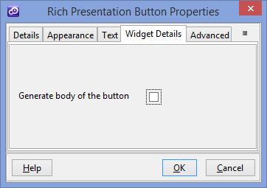

* **Generate body of button** – Enable / Disable the generation to the body of the button.

**How it works**

This widget overrides the default back-button behavior, registers an event listener for the backbutton event with an Edge button (creates a relationship between the device back button and an Edge button).

**Supported Platforms**

* Android
* BlackBerry WebWorks (OS 5.0 and higher)
* Windows Phone 7 and 8